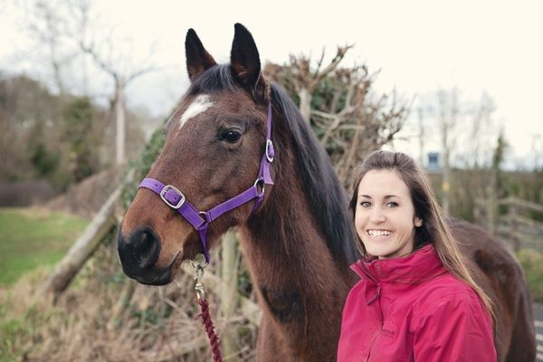

Is Your Horse Saying Yay or Neigh? An Insight into Equine Body Language and Communication

About the Talk:

About the Speaker:
Anna Haines BSc (Hons) MSc CAB
Anna is a Clinical Animal Behaviourist, a full member of the Association of Pet Behaviour Counsellors (APBC) and is registered with the Animal Behaviour and Training Council (ABTC). She has been passionate about horses since a young age and has spent her career working for animal welfare organisations around the world. Having managed animal welfare establishments in the UK and abroad Anna completed her Masters degree in Applied Animal Behaviour and Welfare to pursue her goal of becoming a Clinical Animal Behaviourist. She has since worked for several well-known equine charities, providing her services both within this country and internationally, working with equine owners from a variety of backgrounds and cultures and gaining extensive experience with horses, donkeys and mules. Now settled in beautiful Devon Anna is Equine Behaviourist for The Mare and Foal Sanctuary, whilst also continuing her freelance work as an equine behaviourist for private clients and writing for Horse and Rider Magazine.

