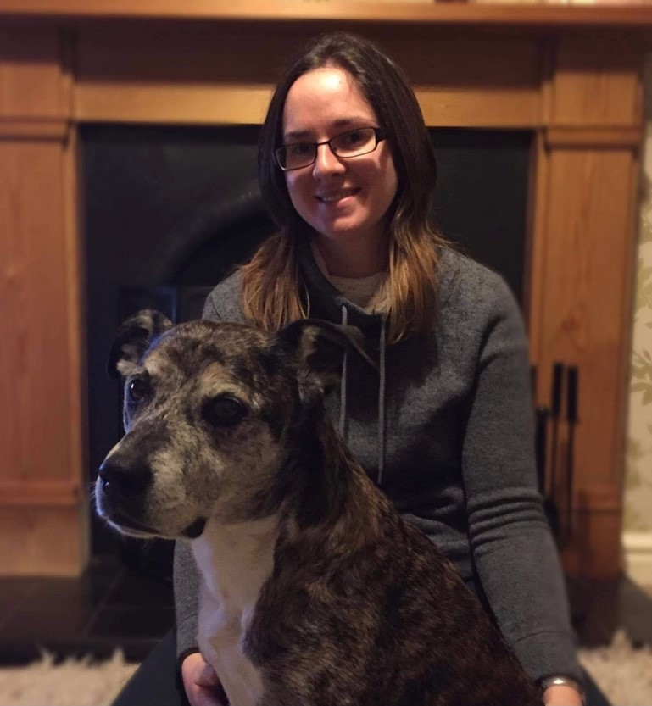
An Approach to Behaviour Cases: Assessment and Treatment Structure. Part 1: Separation-related Behaviour
About the Talk:
Working in practice, it is not unusual to see cases presented as separation anxiety. However, there could be multiple reasons why a dog shows unwanted behaviours when left alone, or when caregivers are preparing to leave. By using case based examples this webinar plans to explore the different characteristics cases may present and how this can help us assess the motivational and emotional differentials. Practical treatment will also be explored and suggested.

About the Speaker:
Lynn Hewison MSc FHEA CCAB
Lynn is a Certificated Clinical Animal Behaviourist (CCAB) through ASAB Accreditation and on the ABTC register as a Clinical Animal Behaviourist (CAB). Lynn is currently a Teacher Practitioner in Clinical Animal Behaviour at the University of Lincoln, U.K. She consults on behaviour cases referred to the Animal Behaviour Clinic at the University of Lincoln and teaches on both post graduate and undergraduate courses, she is also Co-Programme Leader for the MSc in Clinical Animal Behaviour. Lynn has a wealth of experience working with dogs with behaviour problems through consulting in the clinic and also through time spent with dogs in rescue. She has a strong interest in clinical animal behaviour, particularly in the development of treatment plans and problem prevention for pets in homes as well as those in rescue. Having previously been the lead tutor on the Life Skills for Puppies courses Lynn also has experience working with dogs and clients in class settings. Although she no longer teaches puppy classes she continues to run classes for adult dogs through her own dog training business.

