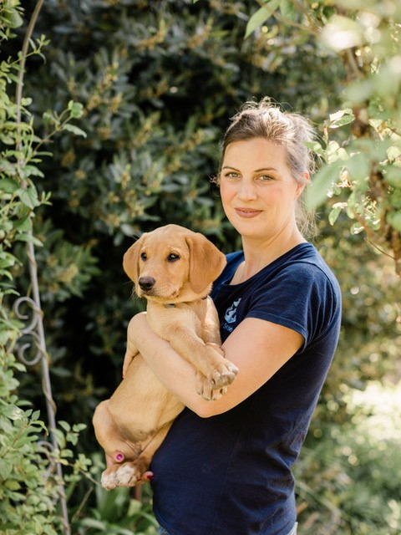

Pandemic Puppies: Problem Prevention
About the Talk:
All new puppy owners hope for a pet that fits in with their lifestyle and remains with them long past puppyhood. They will often seek advice on typical puppy problems from all sorts of different sources - from pet professionals through to social media, the internet and friends and family. Confusion soon arises when contradictory information is provided, and advice that is inappropriate for an individual puppy can have detrimental outcomes for all involved. In this webinar, Rosie will look at common puppy problems and how the pandemic has impacted the type of concerns expressed by puppy owners. She will provide advice on helping caregivers address these difficulties and preventing them from developing into more serious, longer-term problems.

About the Speaker:
Rosie Bescoby runs Pet Sense based in Bristol and North Somerset. She is passionate about sharing her knowledge to impart appropriate and accurate information to benefit the welfare of pets and the human-animal bond. With a degree in Zoology & Psychology and a post-graduate diploma in Companion Animal Behaviour Counselling, Rosie is an ASAB Certified Clinical Animal Behaviourist (CCAB), a full member of the Association of Pet Behaviour Counsellors (APBC) and a member of the Association of Pet Dog Trainers (APDT no.1006). She is registered as both a Clinical Animal Behaviourist and an Animal Training Instructor with the Animal Behaviour and Training Council (ABTC). Rosie is a guest lecturer for veterinary students, veterinary nursing students, and animal behaviour and training students and frequently conducts staff training for veterinary practices. She is currently the APBC Press & Media Officer and regularly contributes to magazines, both pet owner and veterinary publications (including peer-reviewed journals), features on TV and radio, and works with various pet and veterinary-based companies.

